**Advanced Programming Practices**

Hackerrank Week-13

Name: Ronit Kumar Reg: RA2111032010009 Section: T2 Branch:CSE w/s OT

**Ques 1:**  Minimum Loss

**Problem:**

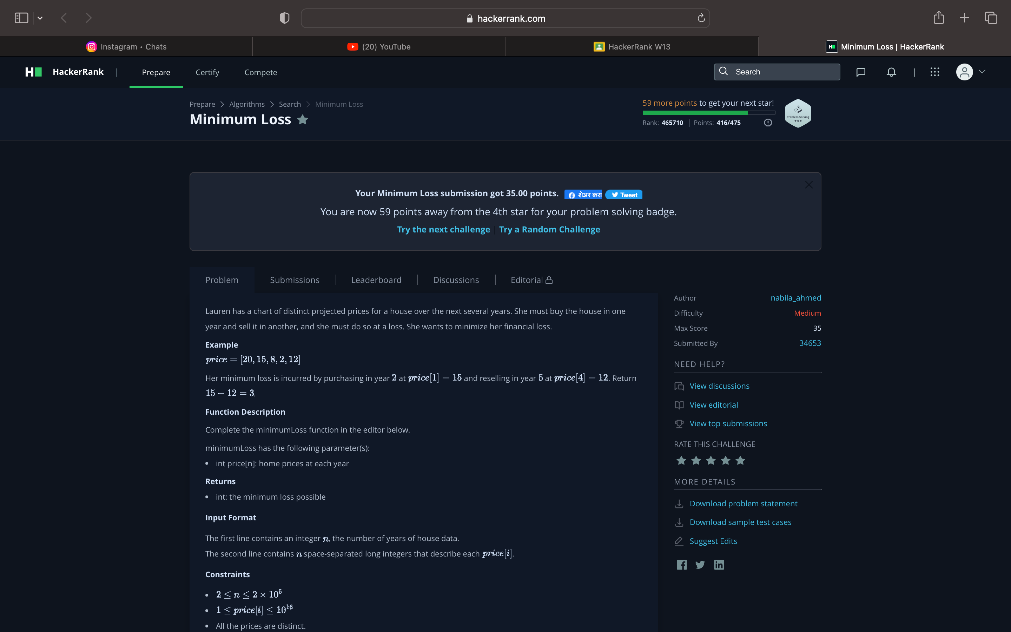

**Code:**

n = **int**(**input**())

arr = **list**(**map**(**int**,**input**().split()))

di = {arr[i]:i **for** i **in** **range**(n)}

arr = **sorted**(arr)

m=10000000

**for** i **in** **range**(1,n):

**if** di[arr[i]]<di[arr[i-1]]:

        m=**min**(m,arr[i]-arr[i-1])

**print**(m)

**Output:**

